
B.Tech - Odd Sem : Semester in Exam-I Academic Year:2023-2024
22EC2106 - PROCESSORS & CONTROLLERS
Set No: 3
Time: |  | Max.Marks: 50
S.NO | Answer All Questions | Choice | SCHEME of Evaluation | Marks | CO | CO BTL | COI BTL
1. | Answer all the questions |  |  | 12Marks | CO1 | 3 | 2
1.A. | How to calculate the 20 bit physical address in 8086 processor?  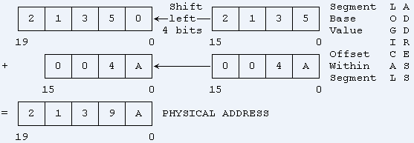 |  | 2Marks | 2Marks | CO1 | 3 | 2
1.B. | Describe the features of the ALU (Arithmetic Logic Unit) in the 8086 microprocessor?  The ALU (Arithmetic Logic Unit) in the 8086 microprocessor performs arithmetic and logical operations on data. |  | 2Marks | 2Marks | CO1 | 3 | 2
1.C. | Describe the function of the Segment register in the 8086 microprocessor?  . The segment registers in the 8086 microprocessor are used to store segment addresses for memory access. |  | 2Marks | 2Marks | CO1 | 3 | 2
1.D. | Name two bit-addressable registers and draw the structure in the 8051 microcontroller.  PSW,TCON,IP, SCON etc |  | 2Marks | 2Marks | CO2 | 3 | 2
1.E. | Mention the structure of the IE (Interrupt Enable) register in the 8051 microcontroller?  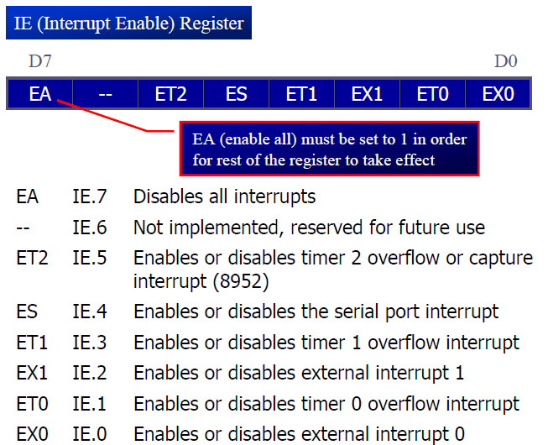 |  | 2Marks | 2Marks | CO2 | 3 | 2
1.F. | Describe the status of the PSW (Program Status Word) register in the 8051 microcontroller with an example?  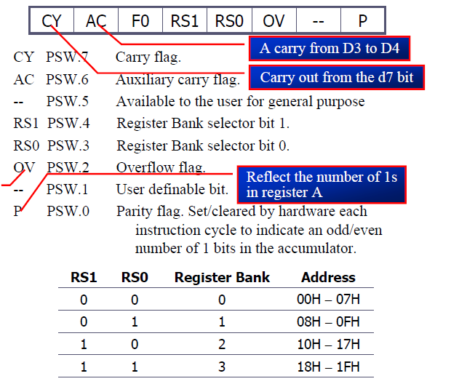 |  | 2Marks | 2Marks | CO2 | 3 | 2
2. | Answer all the questions |  |  | 16Marks | CO1 | 3 | 3
2.A. | Illustrate the following Signals in 8086 and writeits direction (input or output): (i) INTR (ii) ALE (iii) HOLD  INTR Interrupt Request  This is a triggered input. This is sampled during the last clock cycles of each instruction to determine the availability of the request. The processor enters the interrupt acknowledge cycle if any interrupt request is pending.  This signal is active high and internally synchronized.  ALE:(Address Latch Enable) Used to demultiplex the address and data lines using external latches.  HOLD:Input signal to the processor form the bus masters as a request to grant the control of the bus.  Usually used by the DMA controller to get the control of the bus. |  | Each signal contains 1.35 marks | 4Marks | CO1 | 3 | 2
2.B. | Describe the 8086-microprocessor register indirect addressing mode and direct addressing mode with an example  Here, the effective address of the memory location at which the data operand is stored is given in the instruction.  The effective address is just a 16-bit number written directly in the instruction.  Example:  MOV BX, [1354H]  MOV BL, [0400H]  In Register indirect addressing, name of the register which holds the effective address (EA) will be specified in the instruction.  Registers used to hold EA are any of the following registers:  BX, BP, DI and SI.  Content of the DS register is used for base address calculation.  Example:  MOV CX, [BX] |  | Each addressing modes contains 2 marks | 4Marks | CO1 | 3 | 3
2.C. | Classify any two addressing modes of 8051 and explain the significance of each mode with an example.  Immediate  Register  Direct  Register Indirect  Indexed |  | Each addressing modes contains 2 marks | 4Marks | CO2 | 3 | 2
2.D. | Demonstrate the process involved in selection of Register Bank 2 in 8051? Mention the addresses allotted for first and last register of Register Bank 2?  The process of selecting a register bank in the 8051 microcontroller involves manipulating the "RS1" and "RS0" bits within the Program Status Word (PSW) register. These bits determine which register bank will be active for subsequent operations.  Access the PSW Register: Load the content of the PSW register into an accumulator or another working register.  Modify RS1 and RS0 Bits: The "RS1" and "RS0" bits are the two least significant bits of the PSW register. They control the selection of the register bank. To select the desired register bank, modify these bits according to the following pattern:  To select register bank 0: Set both "RS1" and "RS0" to 0.  To select register bank 1: Set "RS1" to 0 and "RS0" to 1.  To select register bank 2: Set "RS1" to 1 and "RS0" to 0.  To select register bank 3: Set both "RS1" and "RS0" to 1.  Update the PSW Register: After modifying the "RS1" and "RS0" bits to select the desired register bank, write the modified value back into the PSW register to apply the changes. |  | Bank selection 2 mark and bank address contain 2 marks | 4Marks | CO2 | 3 | 3
3. | Answer the questions | choice Q-4 |  | 11Marks | CO1 | 3 | 3
3.A. | Explain the purpose and operation of the flag register in the 8086 microprocessor.  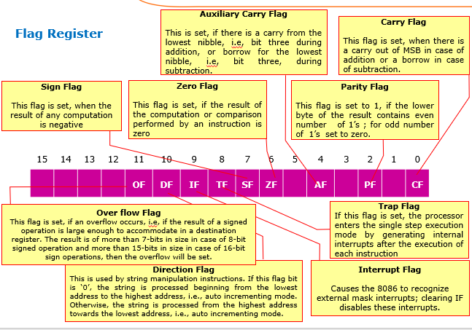 |  | Minimum 5 flags detail required for 5 marks | 5Marks | CO1 | 3 | 2
3.B. | Develop an 8086 ALP to find the largest number in an array of ten bytes. Add comments to your program  org 100h  MOV SI,5000h  MOV AL,0FFH  MOV CL,0AH  Back: CMP AL,[SI]  JNC L1  MOV AL, [SI]  L1: INC SI  LOOP Back  MOV [5020h], AL  HLT |  | Program with comment 6 marks | 6Marks | CO1 | 3 | 3
4. | Answer the question |  |  | 11Marks | CO1 | 3 | 3

4.A. | Discuss the following Instructions with the help of Syntax and Examples? (i)OR AX, AX (ii) AND AX, [0ABCDH] (iii) RCL AL,01H (iv) RCR AL,01H (v) RCL (vi) RCR  Logical OR with Ax  Logical AND with address specified content  Rotate with carry left for Al reg one time  Rotate with carry right for Al reg one time  Rotate with carry left  Rotate with carry left |  | Each instruction carries 1 mark (consider any 5) | 5Marks | CO1 | 3 | 2
4.B. | Write a program to multiply a data byte located at offset 0430h in 4567h segment to another data byte available at 0431h in the same segment and store the result at 1200h in the same segment.  Org 00h  Mov ds, 4567h  Mov si,0430h  Mov al,[si]  Inc si  Mov ah,[si]  Mov bl,ah  Mul bl  Mov si,1200h  Mov [si],al  ret |  | Program with comment 6 marks | 6Marks | CO1 | 3 | 3
5. | Answer the questions | choice Q-6 |  | 11Marks | CO2 | 3 | 3
5.A. | Describe any 5 logical instructions of the 8051 microcontroller in detail with examples.  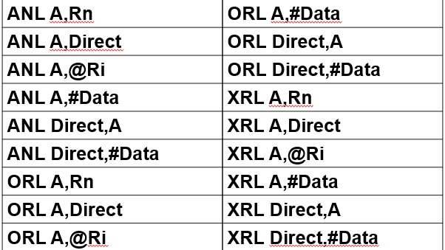 |  | Each instruction carries 1 mark (consider any 5) | 5Marks | CO2 | 3 | 2
5.B. | Write an 8051 Microcontroller program to copy a block of 10 bytes of data from 40H to 50H.  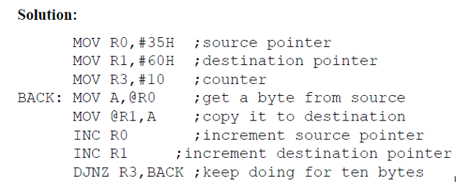 |  | Program with comment 6 marks | 6Marks | CO2 | 3 | 3
6. | Answer the question |  |  | 11Marks | CO2 | 3 | 3
6.A. | Write an ALP to transfer the character "KLU" serially using 8051 microcontroller?  ORG 0H  MOV TMOD,#00100000B------(20H)  MOV TH1,#-3  MOV SCON,#01010000B-------(50H)  SETB TR1  AGAIN:MOV A,# ” “  ACALL TRANSFER  MOV A,# ”K“  ACALL TRANSFER  MOV A,# ”L“  ACALL TRANSFER  MOV A,# ”U“ TRANSFER: MOV SBUF,A  ACALL TRANSFER HERE: JNB TI, HERE  MOV A,# ” “ CLR TI  ACALL TRANSFER RET  SJMP AGAIN  END |  | Program with comment 6 marks | 5Marks | CO2 | 3 | 2
6.B. | Write an ALP to transfer the contents of the registers R0, R1 and R2 respectively of bank 0 to the registers R0, R1 and R2 respectively of bank 1 using stack operation.  PUSH R0  PUSH R1  PUSH R2  SETB PSW.3  POP R2  POP R1  POP R0 |  | Program with comment 6 marks | 6Marks | CO2 | 3 | 3

Key & Scheme HOD
prepared by
Dr.N.Prabakaran
Course Coordinator

